**FORMAN CHRISTIAN COLLEGE**

**(A CHARTERED UNIVERSITY)**



**Embedded Systems (CSCS 306)**

**FALL-2019**

**LAB-07**

**LED Arduino Library**

**Group Members:**

* Mohammad Usman 20-10558
* Haris Naseer 20-10612
* Abeer Butt 20-10596

**Introduction:**

The aim of the lab was to test our skills in creating a library that can work with variable number of LEDs. This lab consists of only one LabTask.

**LabTask:** In this LabTask, we had to create a library. We made a **.h** file (declaration) and a **.cpp** (definition). In the header file, we declared the class, methods and attributes. We had to make various functions such as upCount, downCount, shiftLeft, shiftRight and allOff.

**Working Code:**

**LED.h**

#include <Arduino.h>

class LedCounter

{

public:

LedCounter(int noOfLeds, int pins[]);

void begin();

void upCount();

void downCount();

void shiftLeft();

void shiftRight();

void allOff();

private:

int _noOfLeds; // number of leds

int _pins[12]; // max pins

int _length; // redundant

};

**LED.cpp**

#include "LedCounter.h"

LedCounter :: LedCounter(int noOfLeds, int pins[])

{

_length = noOfLeds;

_noOfLeds = noOfLeds;

for (int i = 0; i < _length; i++)

{

_pins[i] = pins[i];

}

}

void LedCounter :: begin()

{

for (int i = 0; i < _length; i++)

{

pinMode(_pins[i], OUTPUT);

Serial.print("Pin: ");

Serial.println(_pins[i]);

}

}

void LedCounter :: upCount()

{

for (int n = 0; n < pow(2, _length); n++)

{

for (int i = 0; i < _length; i++)

{

if (bitRead(n, i) == 1)

{

digitalWrite(_pins[i], HIGH);

}

else

{

digitalWrite(_pins[i], LOW);

}

}

delay(500);

}

}

void LedCounter :: downCount()

{

for (int n = pow(2, _length); n >= 0; n--)

{

for (int i = 0; i < _length; i++)

{

if (bitRead(n, i) == 1)

{

digitalWrite(_pins[i], HIGH);

}

else

{

digitalWrite(_pins[i], LOW);

}

}

delay(500);

}

}

void LedCounter :: shiftLeft()

{

// turn on leds

for (int j = 0; j < _length; j++)

{

digitalWrite(_pins[j], HIGH);

delay(500);

}

delay(500);

// turn off leds

for (int j = 0; j < _length; j++)

{

digitalWrite(_pins[j], LOW);

delay(500);

}

}

void LedCounter :: shiftRight()

{

// turn on leds

for (int j = _length - 1; j >= 0; j--)

{

digitalWrite(_pins[j], HIGH);

delay(500);

}

delay(500);

// turn off leds

for (int j = _length - 1; j >= 0; j--)

{

digitalWrite(_pins[j], LOW);

delay(500);

}

}

void LedCounter :: allOff()

{

for (int i = 0; i < _length; i++)

{

digitalWrite(_pins[i], LOW);

}

}

**Main**

#include <LedCounter.h>

const int noOfPins = 4;

int pins[noOfPins] = {2, 3, 4, 5}; // arduino pins

LedCounter lc(noOfPins, pins); // instance

void setup()

{

// put your setup code here, to run once:

Serial.begin(9600);

lc.begin(); // put pins in OUTPUT mode

lc.upCount(); // call upCount function

lc.allOff(); // turn off all LEDs

delay(2000);

lc.downCount(); // call downCount function

lc.allOff(); // turn off all LEDs

delay(2000);

lc.shiftLeft(); // call shiftLeft function

lc.allOff(); // turn off all LEDs

delay(2000);

lc.shiftRight(); // call shiftRight function

lc.allOff(); // turn off all LEDs

}

void loop()

{

// put your main code here, to run repeatedly:

}

**Circuit Diagram:**

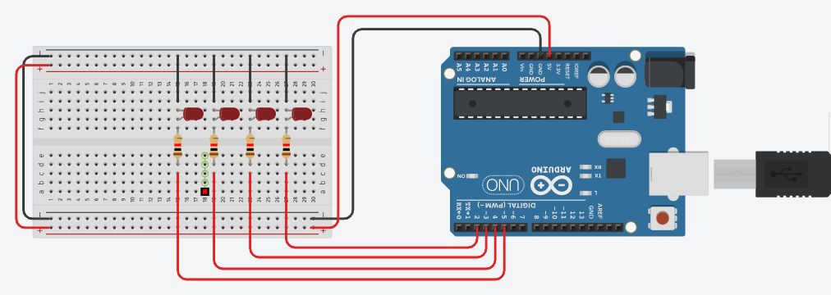

**Running Project Image:**

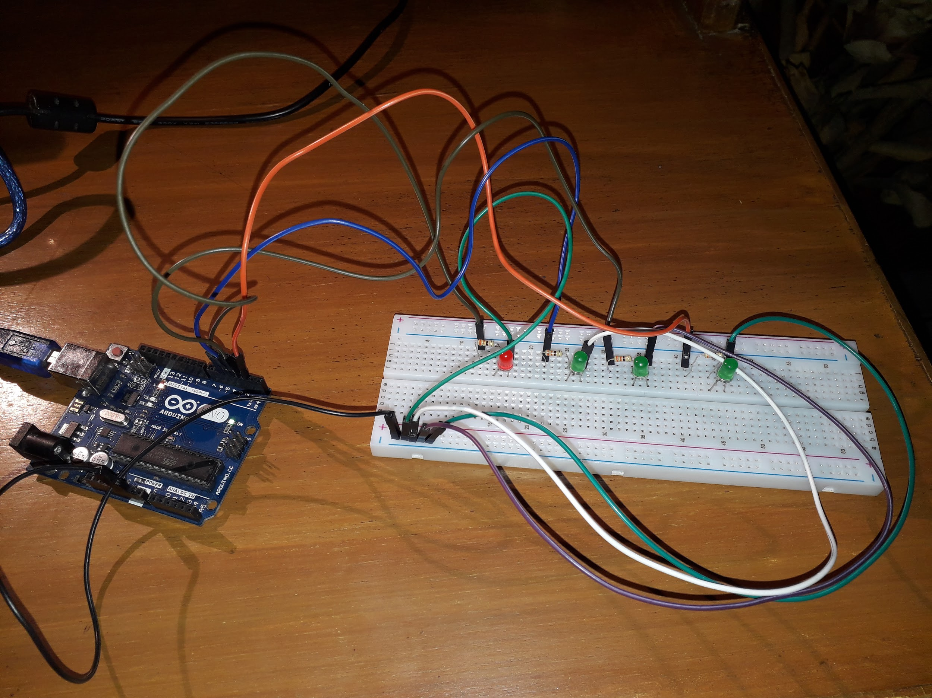

**Running Program Screenshots:**

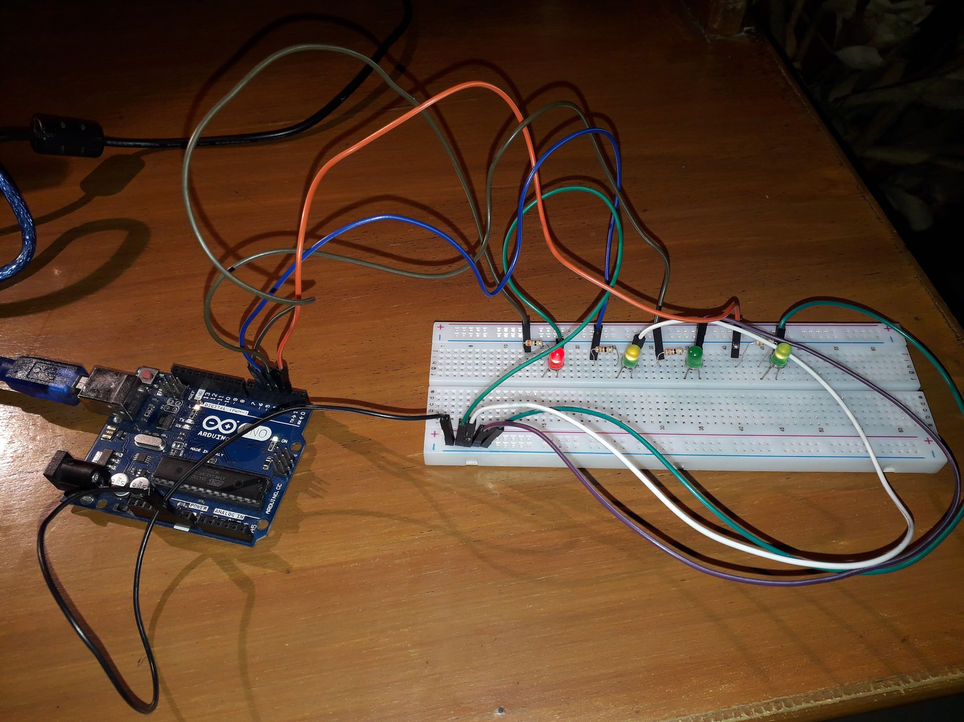

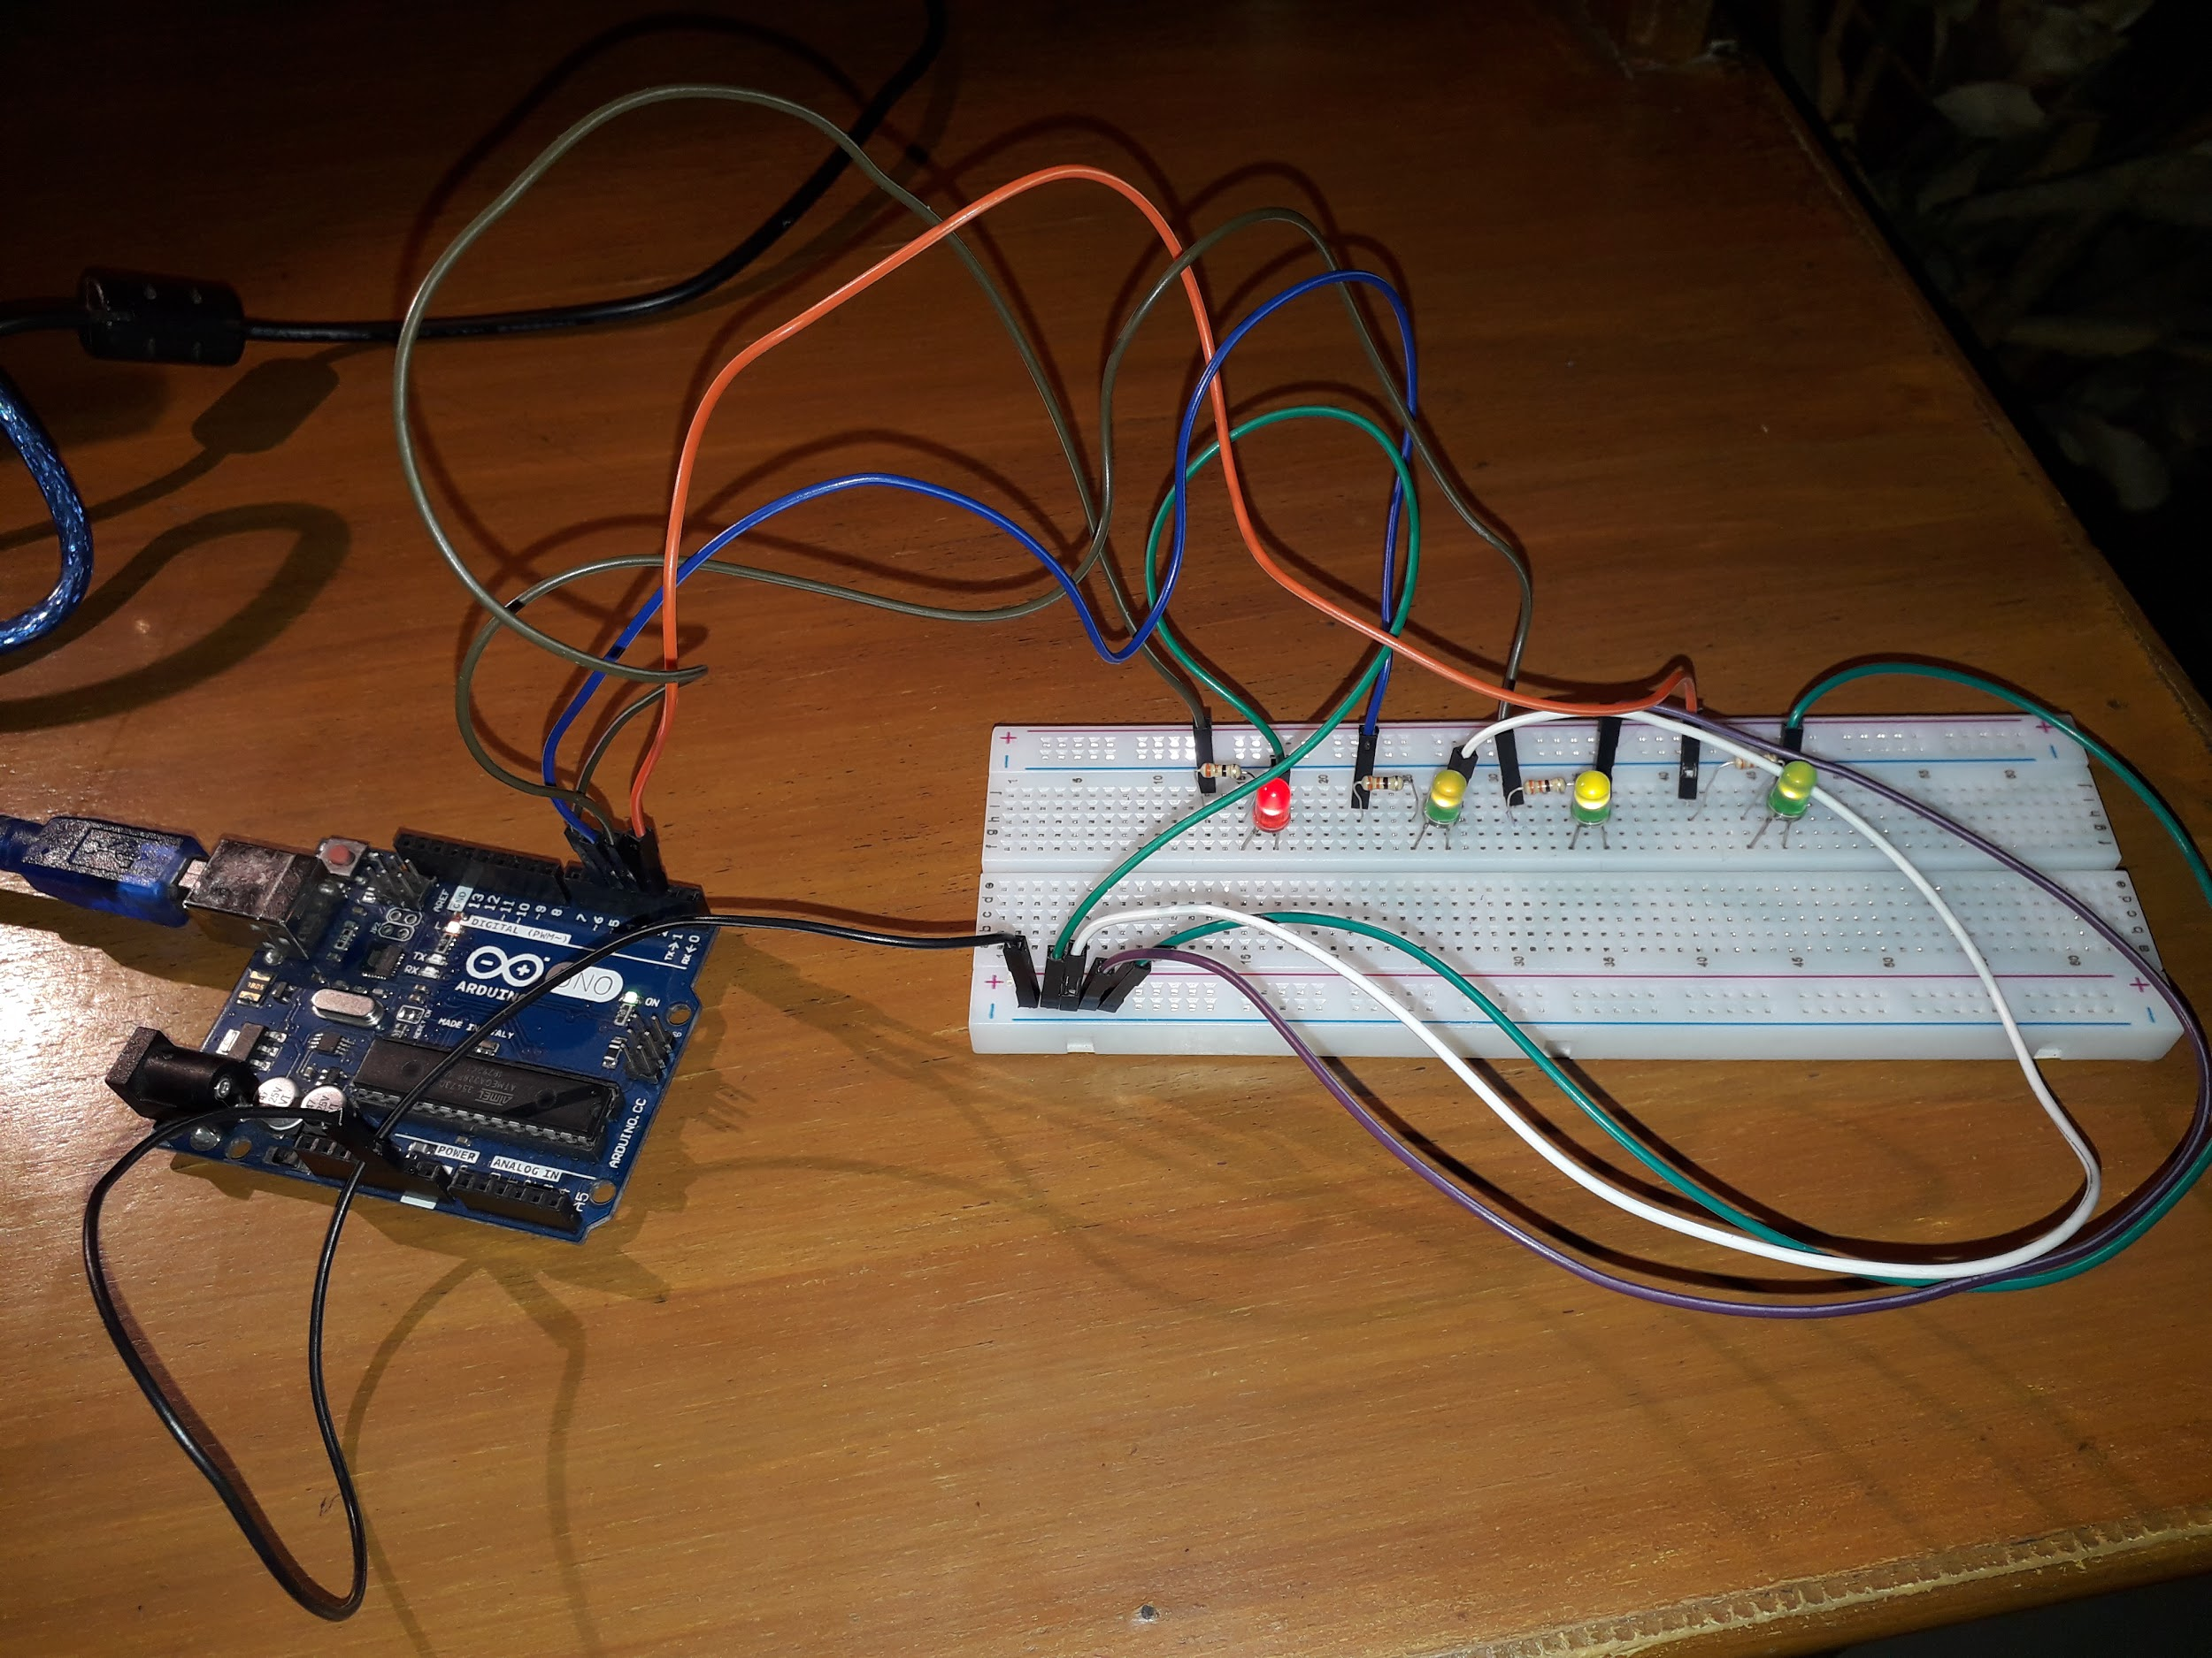

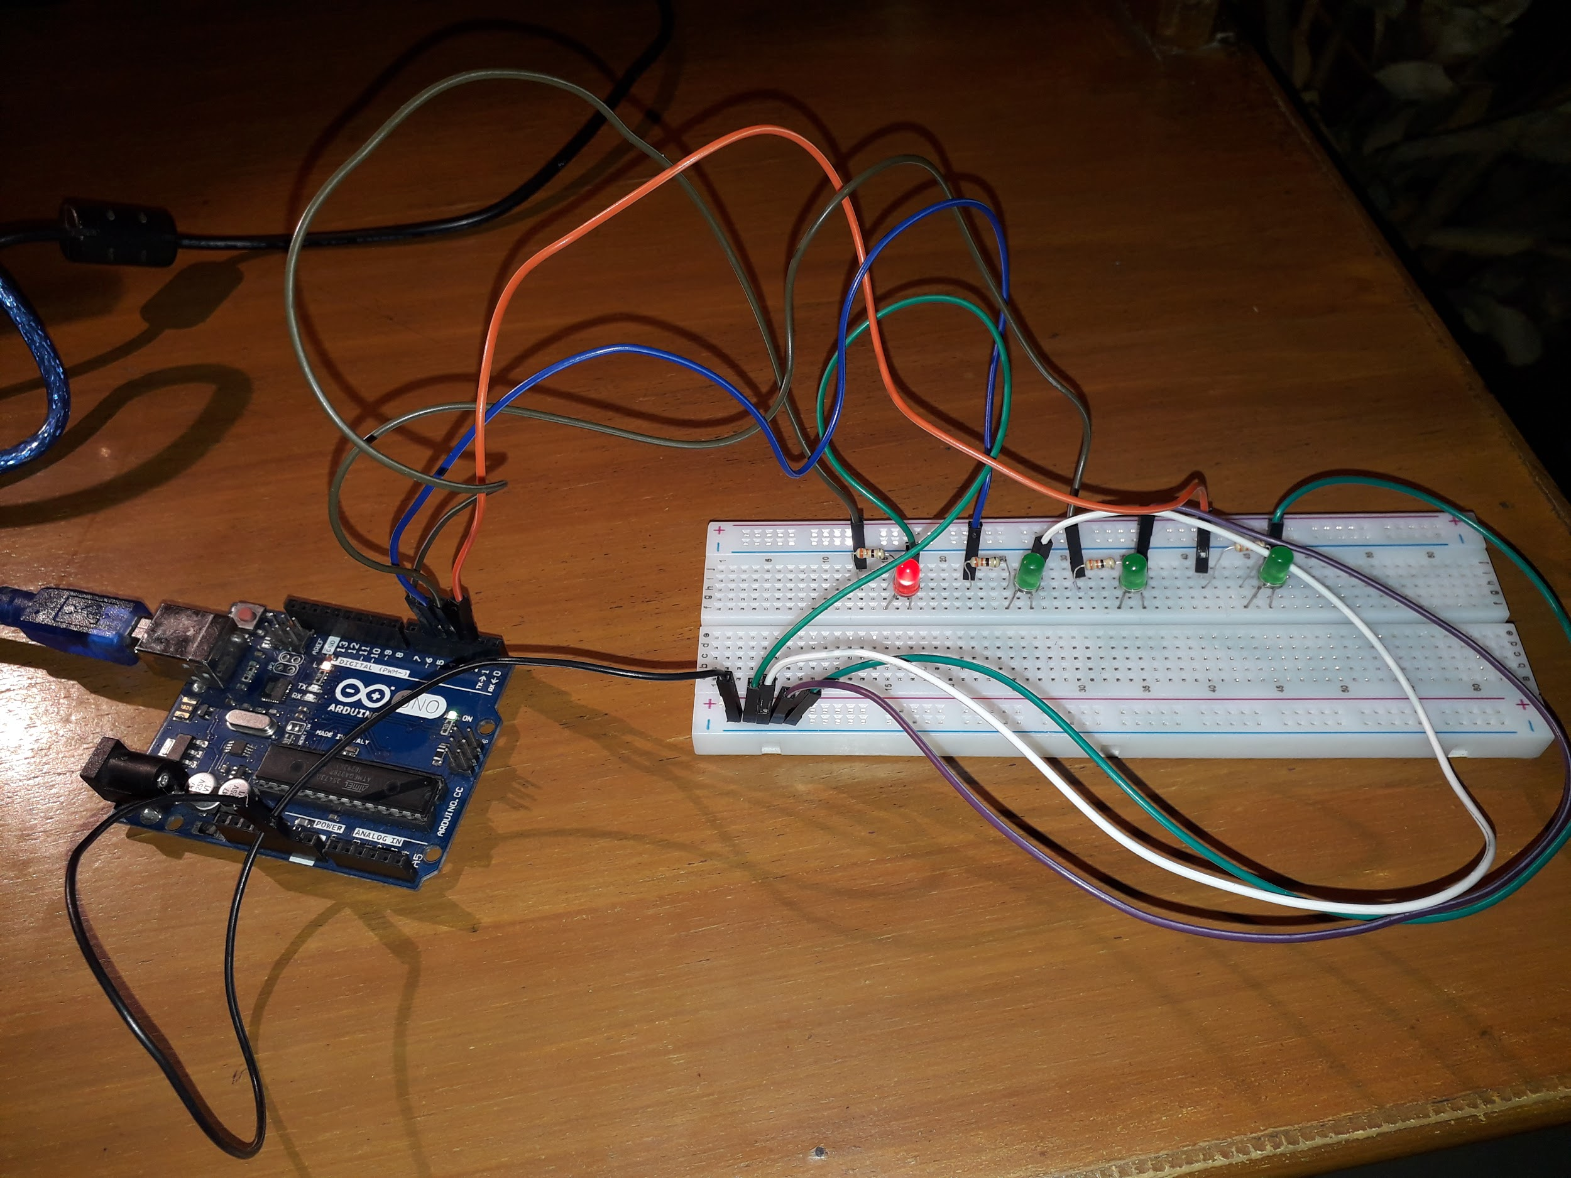

**References:**

* <https://learn.adafruit.com/adafruit-arduino-lesson-2-leds/blinking-the-led>
* <http://blog.industrialshields.com/en/how-to-calculate-the-value-raised-to-a-power-with-arduino-ide/>
* <http://www.multiwingspan.co.uk/arduino.php?page=led5>
* <https://www.tinkercad.com>